**Aim:**

To design and implement a **cloud-based Library Book Reservation System** for **SIMATS Library** using **Zoho Creator**, where students can search, reserve, and manage books online, thereby demonstrating the **Software as a Service (SaaS)** model.

**Procedure:**

**Login to Zoho Creator**

* Open Zoho Creator and sign in with your Zoho account.

**Create a New Application**

* Click **Create Application → From Scratch**.
* Name it: *SIMATS Library Book Reservation System*.

**Design the Book Reservation Form**

Create a form named **Book Reservation Form** with the following fields:

* Reservation ID (Auto-generated)
* Student Name (Text)
* Register Number (Number)
* Email ID (Email)
* Contact Number (Phone)
* Book Title (Text)
* Author Name (Text)
* Book ID (Text / Auto-generated)
* Reservation Date (Date Picker – default = today)
* Status (Dropdown: Reserved, Issued, Cancelled)

**Design the Book Inventory Form**  
Create another form named **Book Inventory** with the following fields:

* Book ID (Auto-generated)
* Book Title (Text)
* Author Name (Text)
* Category (Dropdown: Science, Engineering, Medical, Arts, etc.)
* Availability (Dropdown: Available, Not Available)

**Create Reports (Views)**

* **Reservation List** → Displays all reservations with filters by Student Name, Book Title, and Status.
* **Available Books** → Displays all books in inventory where Availability = Available.

### **All Book Reservations:**

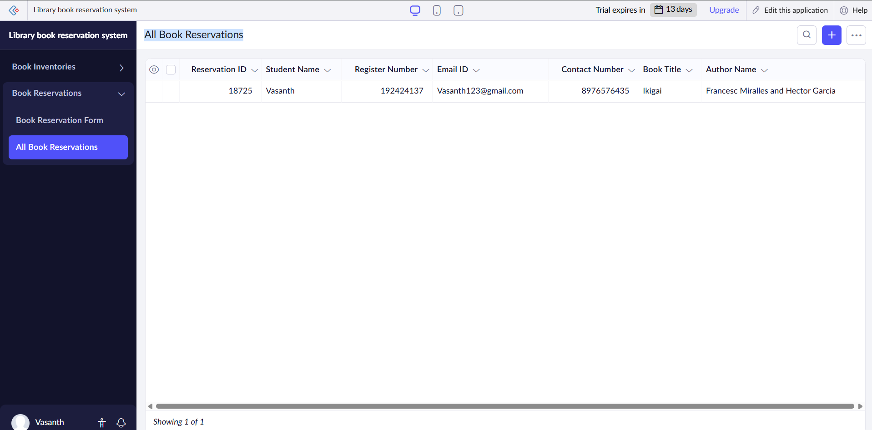

**All Book Inventories:**

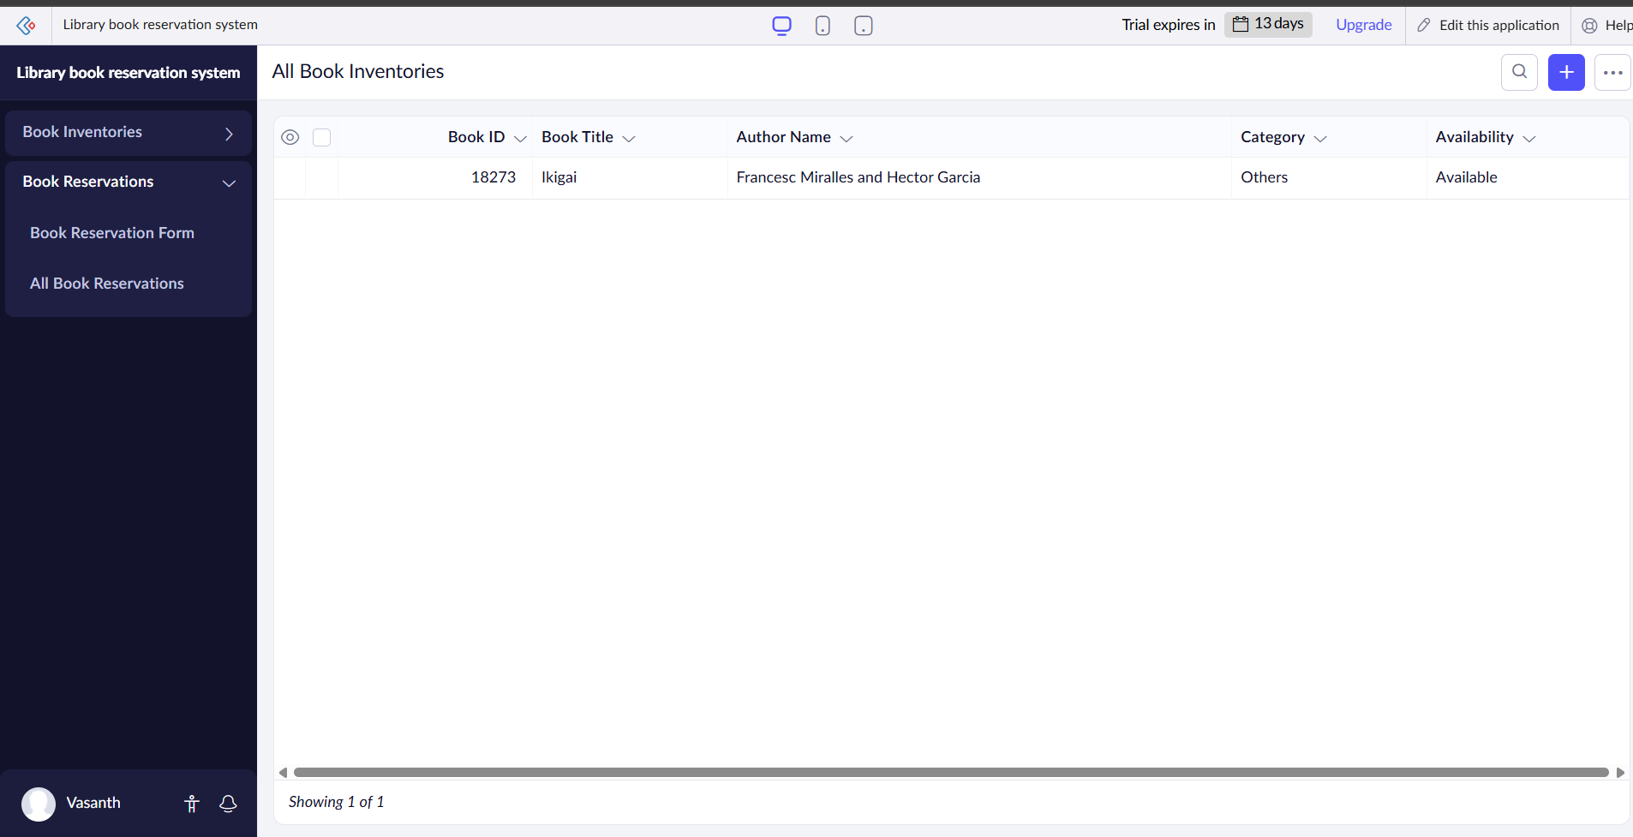

**Result:**

The **Library Book Reservation System** for **SIMATS Library** was successfully developed using **Zoho Creator**.

* Students can **search books and reserve them online**.
* Librarians can **track reservations and book availability** through reports.
* The application is **hosted on Zoho’s cloud**, accessible from anywhere through web or mobile, proving the **SaaS model**.